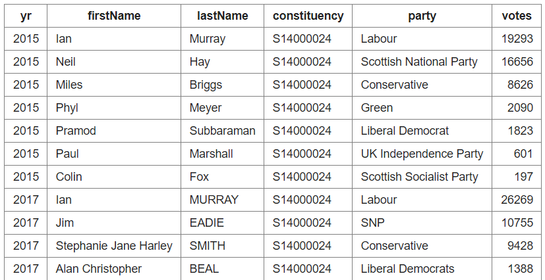

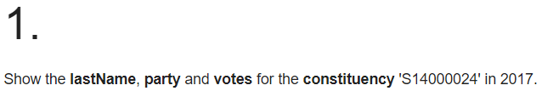

**SELECT lastName, party, votes FROM ge WHERE constituency = 'S14000024' AND yr = 2017 ORDER BY votes DESC**

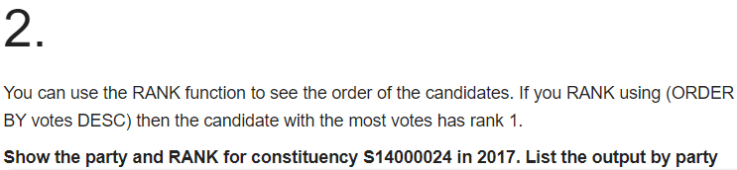

**SELECT party, votes, RANK() OVER (ORDER BY votes DESC) as posn FROM ge WHERE constituency = 'S14000024' AND yr = 2017 ORDER BY party**

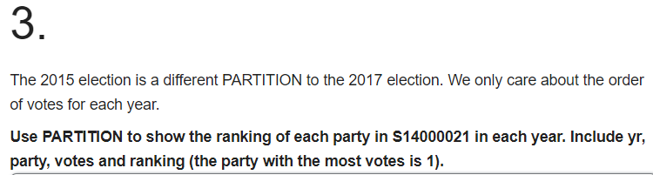

**SELECT yr,party, votes, RANK() OVER (PARTITION BY yr ORDER BY votes DESC) as posn FROM ge WHERE constituency = 'S14000021' ORDER BY party,yr**

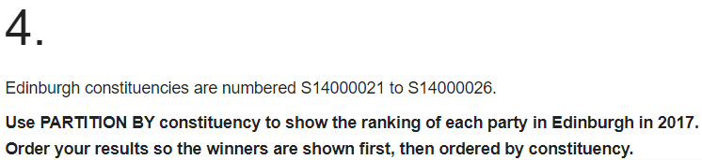

**SELECT constituency,party, votes, RANK() OVER (PARTITION BY constituency ORDER BY votes DESC) AS posn FROM ge WHERE constituency BETWEEN 'S14000021' AND 'S14000026' AND yr = 2017 ORDER BY posn,constituency**

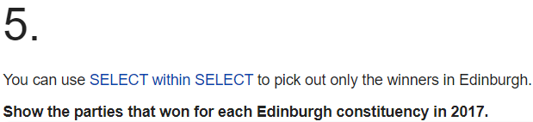

**SELECT constituency, party FROM (SELECT constituency, party, RANK() OVER (PARTITION BY constituency ORDER BY votes DESC) as posn FROM ge WHERE constituency BETWEEN 'S14000021' AND 'S14000026' AND yr = 2017) a WHERE a.posn = 1**

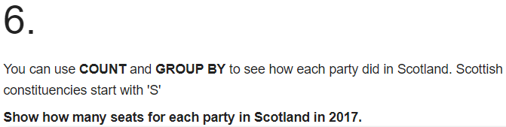

**SELECT party, COUNT(constituency) from (SELECT constituency, party, RANK() OVER (PARTITION BY constituency ORDER BY votes DESC) as posn FROM ge WHERE constituency LIKE 'S%' AND yr = 2017) a WHERE a.posn = 1 GROUP BY party**